Surname and Initials:  ……………………………………………………  Reyneke, R | Session Day:  ………………  Wednesday | Group no  …………  6
Student number:


DEPARTMENT OF PHYSICS
FSK 116
Practical Report
SIMPLE HARMONIC MOTION (OSCILLATIONS) – Using a simple pendulum
Part A: Background Questions
Question 1: A simple pendulum consists of a light (massless and non-stretchable) string which has a mass (considerably heavier than the string) suspended from the one end while the other end is attached to a fixed point. Initially the string and the mass will be in the equilibrium position – hanging straight down. If the mass is now displaced by a small distance from the equilibrium position and let go, answer the following questions in terms of the motion that you observe.
Question 1: Describe what you understand by the period of the motion.
A period (T) is the time required for one complete cycle of the motion of the pendulum. As the frequency of the motion increases, the period of the motion decreases. Frequency and Period are in reciprocal relationships and can be expressed mathematically as: Period equals the total time divided by the number of cycles.

Question 2: What do you understand by the term frequency of this system/simple pendulum?
Frequency is the number of cycles completed of a repeating event (like the swing of the pendulum) per unit of time. Frequency and Period are in reciprocal relationships and can be expressed mathematically as: F = $\frac{1}{T}$ , where F is Frequency and T is time.
Question 3: When the simple pendulum is displaced from the equilibrium position and the string makes an angle θ with the vertical equilibrium position, sketch the pendulum, showing where it is attached, the angle θ , and the displacement of the mass from equilibrium. Now also draw a free-body diagram showing all the forces acting on the mass. Determine the net force acting on the mass.
Question 4: In this (SHM) system, this net force is called the restoring, and from pure SHM system (e.g. a mass - spring system), this force satisfies the relationship: $\vec{F}= -k\vec{x}$, where k is the spring constant of the spring used (See chapter 7 in your textbook for more details on springs). In the simple pendulum, show that $k={mg}/l$ . For more information on this see chapter 15.5 in your textbook, Serway and Jewett, 10e. State all assumptions which are made to obtain this relationship.
Question 5. In the pure SHM sytem, the period is found to be $T=2π\sqrt{m/k}$ . Show that the equation for the period for a simple pendulum is given by $T=2π\sqrt{l/g}$. For some guidance with this, see Chapter 15.5 in your textbook, Serway and Jewett, 10e.
Part B: Experiment
AIM: Determine the relationship between the following:
(i) the length of the simple pendulum and the period and
(ii) the displacement of a simple pendulum from equilibrium and the period of the pendulum.

Experimental apparatus:
- A piece of string – about 1 – 1.5 m in length.
- A ruler (or tape-measure) for measuring length of the string.
- A mass tied to one end of the string. The mass should be heavy compared to the mass of the string. A pill vial filled with water, a small container filled with liquid, a small stone have been found to work well (see Figure 1 below).
- Some sticky tape or Prestik to secure the other end of the string to a convenient place such as the upper member of a door frame (see Figure 2 below).
- A stopwatch (the one on a cell phone is sufficient).
- A calculator.

Experimental procedure:
Part 1:
- Tie the mass to one end of the string, see Figure 1 for examples.
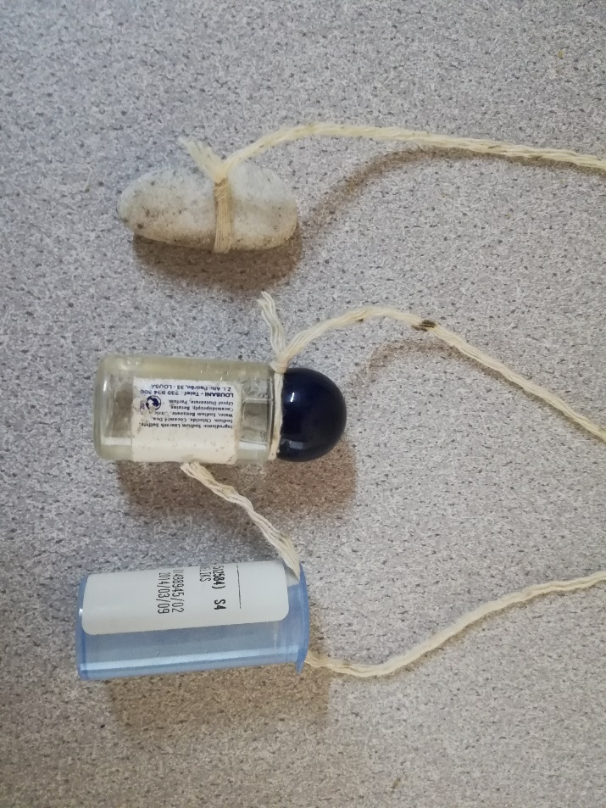
Figure 1: Examples of how to attach the mass to the string.
- Secure the other end of the string to the tape or Prestik, allowing the string and mass to swing freely below, see Figure 2.
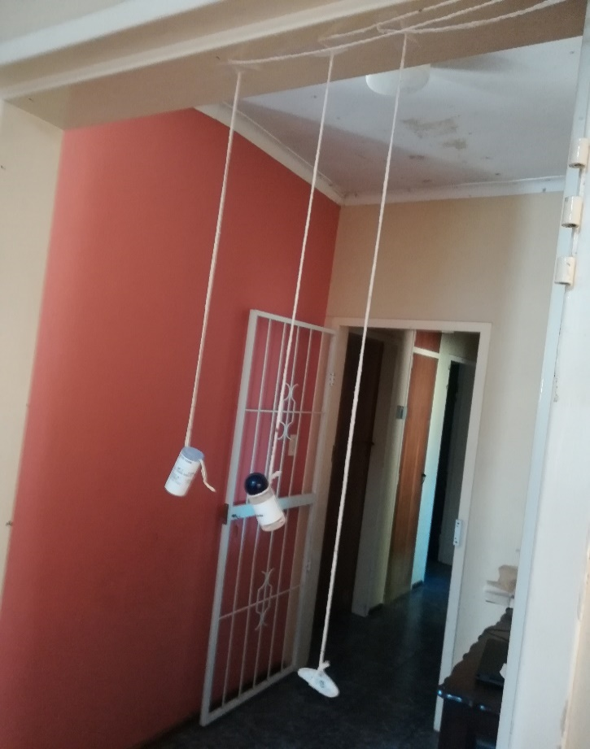
Figure 2: Hanging pendulums attached with tape on a door frame.
- Measure the length of the string of the pendulum as it hangs, and note it as 1st Length in Table 1.
- Displace the mass a small distance from the equilibrium position (where it does not swing back and forth), about 5 - 10 cm, and then let it go. Be careful not to lift the mass so that the tension is slack.
- Measure the time it takes for 10 oscillations, and fill it in on the table below.
- Repeat steps 4 and 5 ten times, recording the time for 10 oscillations for the 1st length.
- Shorten the length of the string, and repeat steps 2 – 6 five more times for the 2nd, 3rd, 4th, 5th, and 6th Lengths. It is ctitical that these length measures span / cover the whole length of the string. That is, do not choose all of them from a small portion of the string.

Table 1
Title: Table showing the Time for 10 oscillations (s) and the Period(s) at different lengths of string (m).
Measurement: | 1st length: l₁ = 1 m |  | 2nd Length: l₂ = 0.8 m |  | 3rd Length:l₃ = 0.69 m
 | Time for 10 oscillations (s) | Period  (s) | Time for 10 oscillations (s) | Period  (s) | Time for 10 oscillations (s) | Period  (s)
1 | 19,72 | 1,97 | 18,95 | 1,90 | 17,10 | 1,71
2 | 19,73 | 1,97 | 18,88 | 1,89 | 17,44 | 1,74
3 | 19,92 | 1,99 | 18,93 | 1,89 | 16,97 | 1,70
4 | 19,67 | 1,97 | 18,86 | 1,89 | 17,15 | 1,72
5 | 19,77 | 1,98 | 18,87 | 1,89 | 17,18 | 1,72
6 | 20,13 | 2,01 | 18,94 | 1,89 | 17,25 | 1,73
7 | 19,79 | 1,98 | 18,82 | 1,88 | 17,11 | 1,71
8 | 19,66 | 1,97 | 18,89 | 1,89 | 17,25 | 1,73
9 | 19,78 | 1,98 | 18,69 | 1,87 | 17,19 | 1,72
10 | 20,05 | 2,01 | 18,82 | 1,88 | 17,12 | 1,71
Average Period |  | 1,98 |  | 1,89 |  | 1,72

Measurement: | 4th length: l₄ = 0.54 m |  | 5th Length: l₅ = 0.39 m |  | 6th Length:l₆ = 0.25 m
 | Time for 10 oscillations (s) | Period  (s) | Time for 10 oscillations (s) | Period  (s) | Time for 10 oscillations (s) | Period  (s)
1 | 15,34 | 1,53 | 13,62 | 1,36 | 11,36 | 1,14
2 | 15,86 | 1,59 | 13,44 | 1,34 | 11,74 | 1,17
3 | 15,41 | 1,54 | 13,37 | 1,34 | 11,34 | 1,13
4 | 15,48 | 1,55 | 13,51 | 1,35 | 11,47 | 1,15
5 | 15,40 | 1,54 | 13,51 | 1,35 | 11,32 | 1,13
6 | 15,48 | 1,55 | 13,75 | 1,38 | 11,21 | 1,12
7 | 15,53 | 1,55 | 13,37 | 1,34 | 11,29 | 1,13
8 | 15,26 | 1,53 | 13,50 | 1,35 | 11,33 | 1,13
9 | 15,35 | 1,54 | 13,45 | 1,35 | 11,13 | 1,11
10 | 15,08 | 1,51 | 13,49 | 1,35 | 11,64 | 1,16
Average Period |  | 1,54 |  | 1,35 |  | 1,14
Part 2:
- Using any length for the simple pendulum, repeat the experiment for different initial displacements from equilibrium (also called amplitudes).
What is the length of the string for your pendulum?
Length of string is: 0.9 m
- Take note of the first displacement (e.g. the 5 cm) from the equilibrium position and fill it in on Table 2 below.
- Measure the time it takes for 10 oscillations, and fill it in on the Table 2 below.
- Repeat step 10 ten times, recording the time for 10 oscillations using the same amplitude.
- Change the initial amplitude of the pendulum, and repeat steps 9 – 11 two more times for the 2nd and 3rd amplitudes.

Table 2
Title: Table to show Time for 10 oscillations (s) and Period (s) at different displacements from the equilibrium (m).
Measurement: | 1st displacement:  d₁ = 0.1 m |  | 2nd displacement:  d₂ = 0.2 m |  | 3rd displacement:  d₃ = 0.3 m
 | Time for 10 oscillations | Period | Time for 10 oscillations | Period | Time for 10 oscillations | Period
1 | 19,43 | 1,94 | 20,10 | 2,01 | 21,45 | 2,15
2 | 19,39 | 1,94 | 21,34 | 2,13 | 20,53 | 2,05
3 | 19,70 | 1,97 | 20,13 | 2,01 | 21,24 | 2,12
4 | 19,04 | 1,90 | 20,28 | 2,03 | 21,37 | 2,14
5 | 19,34 | 1,93 | 20,63 | 2,06 | 21,36 | 2,14
6 | 19,39 | 1,94 | 20,71 | 2,07 | 21,17 | 2,12
7 | 19,59 | 1,96 | 20,41 | 2,04 | 21,27 | 2,13
8 | 19,41 | 1,94 | 20,75 | 2,08 | 21,73 | 2,17
9 | 19,32 | 1,93 | 20,23 | 2,02 | 21,64 | 2,16
10 | 19,60 | 1,96 | 20,79 | 2,08 | 21,57 | 2,16
Average Period |  | 1,94 |  | 2,05 |  | 2,13

Calculations:
- The values you have recorded in Tables 1 and 2 are for 10 oscillations. Complete the tables by calculating the time it takes for one oscillation – i.e. the period of oscillation for the different lengths and for the different displacements/amplitudes. Then determine the average period for each of the situations.

- What do you notice about the periods of the different lengths of pendulums?
The shorter the length of the string, the less time it takes to complete 10 oscillations, therefore shortening the period. The period and the length of the string are thus directly proportional to each other.

- What do you notice about the periods of the three different displacements of pendulums?
If the displacement from the equilibrium increases, the time for 10 oscillations will also increase, therefore the period will also increase. Period and displacement from the equilibrium are thus directly proportional to one another.

- Using the average periods in Table 1, plot a graph of T vs L.
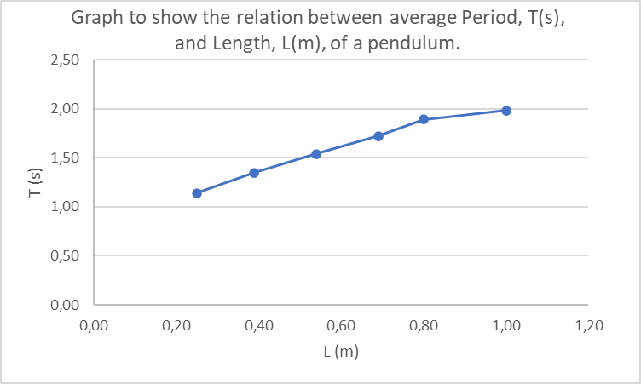
- Comment on the shape of the graph.
There is a linear relationship between the length of the string and the average period of the pendulum. The length of the string and the period of the pendulum are thus directly proportional to one another.

- Using the same data, plot a graph of T² vs L.
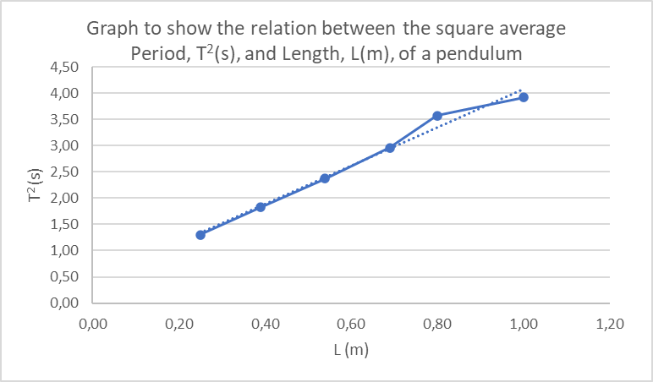

- Calculate the slope of the second graph. Set up the empirical equation (the equation of your graph). Include units (in brackets) for the constants in the equation.

- Using the expression for T obtained in Question 5 (Part A), what is the expression for T-squared?

- Compare your empirical equation (Q7 above) with the expression you got in Q8. What is the relationship between the slope of your graph and g?

- Determine the value of g using the SHM of the simple pendulum.

